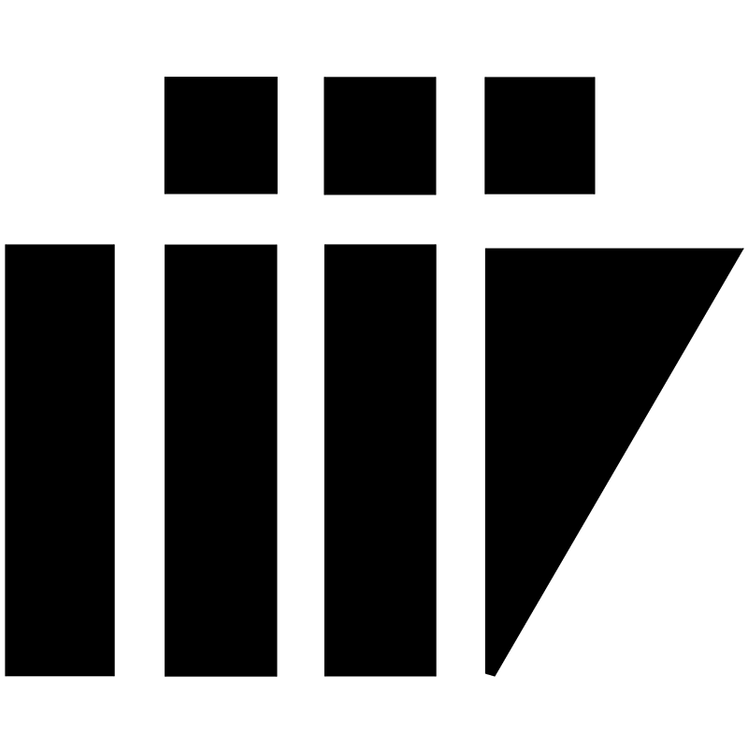
TRAVEL DIARIES

SDLC REJECTED MODELS

VERSION 1.0
AUTHORED BY: INDU,DURGAVIJAYALAKSHMI

REVIEWED BY :

PROJECT NAME - TRAVEL DIARIES

INSTRUCTOR NAME - ASIM BANERJEE

GROUP NO - 05

GROUP MEMBERS : G RAJU KOUSHIK

NILESH CHATURVEDI

SHREYA SINGH

B.INDU

B.DILEEP KRISHNA

AKHIL PEDAPALI

DURGA VIJAYALAKSHMI

RAVI KUMAR PATEL

JITENDRA SINGH

TABLE OF CONTENTS

S.NO TOPIC PAGE NO.

- WATERFALL MODEL 04

- ADVANTAGES 04

- DISADVANTAGES 04

- REASON 05

- ITERATIVE WATERFALL 05

- ADVANTAGES 05

- DISADVANTAGES 06

- REASON 06

- SPIRAL MODEL 06

- ADVANTAGES 07

- DISADVANTAGES 07

12. REASON 07

SDLC MODELS

Rejected Models:

- Waterfall Model:
The waterfall is a linear sequential flow in which progress is seen as flowing steadily downwards (as a waterfall) through the phases of software implementation.This means that any phase in the development process begins only if the previous phase is completed.The Waterfall approach do not define the process to go back to the previous phases to handle the changes in the requirement.The waterfall approach is the earliest approach that was used for software development.

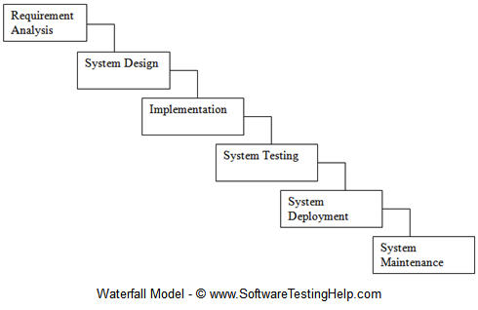

ADVANTAGES:
- Stages and activities are well defined.
- Helps to plan and schedule the project.
- Verification in each stage ensures early detection of errors or misunderstandings.

DISADVANTAGES:
- It is very difficult to go back to previous stage once it is finished.
- It is difficult to change or adjust the scope.
- It is costly and requires more time in addition to detailed plan.

REASON FOR REJECTION:
In this Model ,once we start any phase it will not be flexible to go to the previous phase and correct the errors which are found in the previous stage.There will be no updating and adding additional requirements once the design phase is started.

- Iterative waterfall Model:
An Iterative waterfall model is similar to classical waterfall model.This approach carries less risk than a traditional waterfall approach but is still for more risky and less efficient than other SDLC models.The most commonly occurring issue in this type of scenario is bottle necking. It is desirable to minimize (if not eliminate) human errors during software development.

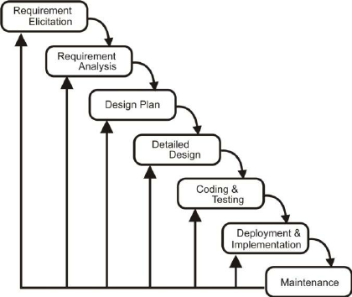

ADVANTAGES:
- In Iterative waterfall model we can only create a high level design of the Application before we actual begin to build the product and define the design solution for entire product.
- In this model we are building the product step -by-step.Hence we can track the defects in any stage which avoids the downward flow of the defects.
- In this model we can get the reliable user feedback and presenting sketches and blue prints of the product to user for their feedback we are effectively asking them to imagine how the product will work.

DISADVANTAGES:
- Each phase of iteration is rigid with no overlaps
- Costly system architecture or design issues may arise because not all requirements are gathered are front for the entire life cycle
- This process can become time consuming and costly

REASON FOR REJECTION:
In this Model ,once we start any phase it will not be flexible to go to the previous phase and correct the errors which are found in the previous stage.In this model Once the design phase is started we cannot go back and change or add additional requirements.As it takes more time to construct design phase so it is not feasible to our project.

- SPIRAL MODEL:
The Spiral model is similar ti the incremental model,with more emphasis placed on risk analysis.The Spiral model has four phases :Planning,Risk analysis,Engineering and Evaluation.A software project repeatedly passes through these iterations.The base line Spiral starting in the Planning phase requirements are gathered and risk is assess ted.Each sub sequence of spiral s build on the base line spiral.

DIAGRAM OF SPIRAL MODEL:

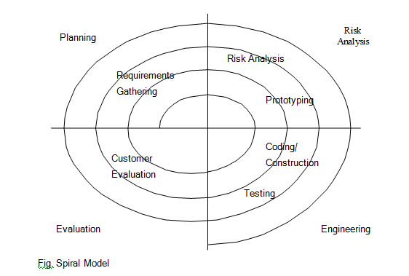

ADVANTAGES:
- High amount of Risk analysis hence,avoidance of risk is enhanced.
- Good for large and mission critical project.
- Strong approval and documentation control
- Additional functionality can be added at a later date.

DISADVANTAGES:
- Can be a costly model to use ,Risk analysis requires highly specific expertise.
- Project Success is highly dependent on risk analysis phase.

REASON FOR REJECTION:
Looping of each cycle takes more time consuming and we have only less time to build a complete project with all requirements and their testing in a given period.

